Purpose:

Our purpose is to provide people with the best possible options for clean healthy foods. We strive to accomplish this through partnering with local farms who lovingly care for the produce that they provide. We also work with national and international suppliers to fill in the gaps that our local farms are unable to fulfill. We harbor on the idea that organic foods can be not only better for you but also taste better. Our goal is to provide availability to as many people as we can. Through our website, permanent store front, and food trucks we believe we can reach more people but also educate more people on the benefits of fresh organic foods.

Target Audience:

The target audience for our site includes several demographics. Many of these are those interested in a healthy lifestyle. These people include athletes, fitness enthusiasts, health conscious eaters, and more. The majority of these will be of the younger generations ranging from 18-35. Because of this, our site will appeal to their more impressionable side. That side includes the ease and variety of ordering as well as the ease of acquiring the product.

Site Map:

Color Scheme:

Typography:

Inconsolata, monospace; PT Serif, serif

Wireframe Sketches:

Large:

Medium:

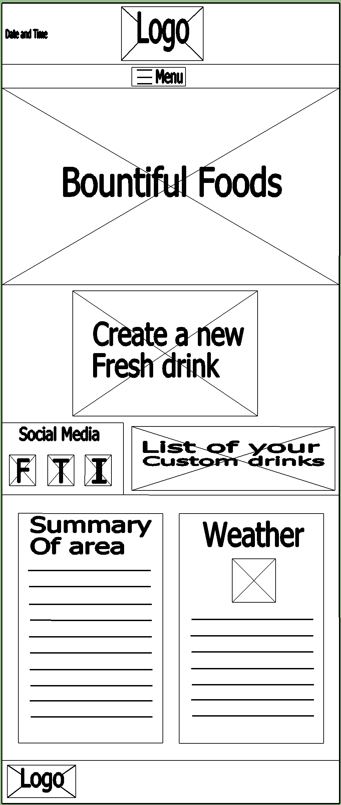

Small:

